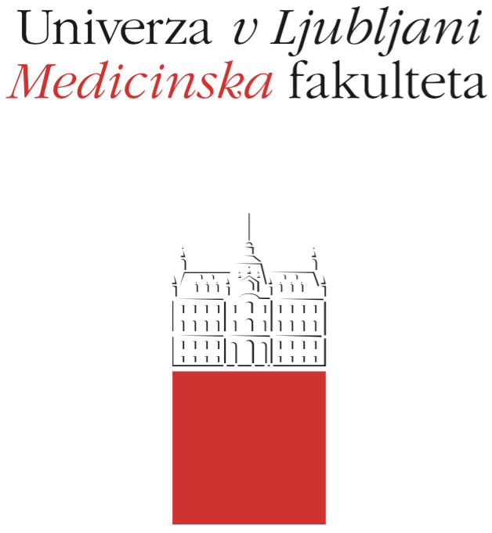

Komisija za študijske zadeve

UL Medicinske fakultete

Vrazov trg 2

SI-1000 Ljubljana

E: ksz@mf.uni-lj.si

T: +386 1 543 7700

Course Regime

Course: METHODS AND TOOLS IN PUBLIC HEALTH

Study Programme:
Medicine Dental Medicine

Year of the Course: 1 2 3 4 5 6

Semester:
Winter Summer

Course type:
Compulsory Elective

Number of ECTS credits: 3

Lecturer(s): prof.dr. Lijana Zaletel-Kragelj

Participating Organisational Units (Departments and Institutes): Chair of Public Health

Parts (Modules) of the Course
Module 1: Methods of Population Health Research
Module 2: Methods of Public Health Intervention

Date of Issue: Sepember 15, 2018

A. General part
- Course objectives
OBJECTIVES
Objectives of the course are:
- to introduce students to epidemiological methods as the most important methods for studying the health of the population and to learn how to calculate the most basic epidemiological measures of health phenomena (e.g. incidence and prevalence rates),
- to introduce students to other methods of studying the health of the population (demographic methods, methods of measuring the global health of the population, methods for assessing environmental risks, etc.),
- to introduce students to medical methods of public health intervention (methods of public health medicine) for managing major public health problems (health promotion, health education, vaccination, screening, harm reduction),
- to introduce students to other (non-medical) methods of public health action to deal with major public health problems (environment risk management methods, complex public health approaches).

COMPETENCES
The competences expected are only first-level competences, so at the end of the module it is expected that students:
- know and understand epidemiological methods as the most important methods for studying the health of the population and to learn how to calculate the most basic epidemiological measures of health phenomena (e.g. incidence and prevalence rates),
- know and understand other methods of studying the health of the population (demographic methods, methods of measuring the global health of the population, methods for assessing environmental risks, etc.),
- know and understand medical methods of public health intervention (methods of public health medicine) for managing major public health problems (health promotion, health education, vaccination, screening, harm reduction),
- know and understand other (non-medical) methods of public health action to deal with major public health problems (environment risk management methods, complex public health approaches)..

- Comprehensive outline of the course organisation
The course METHODS AND TOOLS IN PUBLIC HEALTH is implemented in two modules:
- Module 1: Methods of Population Health Research
- Module 2: Methods of Public Health Intervention
The course is taught in the form of lectures and seminars:
- lectures (15 hours: in Module 1 8 hours and Module 2 7 hours). Participation in lectures is not mandatory, however, it is recommended,
- seminars (15 hours: in Module 1 7 hours and Module 2 8 hours), on which the topics presented in the lectures are upgraded with current events in Slovenia or abroad. The work is divided into work in small groups and work in large groups (major seminars):
• seminar work in small groups: students in a small group, together with the mentor, process more detailed one of the current subject areas; participation is obligatory at all meetings of each group and on the presentation of a seminar topic at a major seminar (in case of non-participation, the student has to give the appropriate apology),
• major seminars: all the small groups briefly present the results of their work and discuss the topic with other students; work is carried out in the main classroom; 70% participation is required, the presence is checked,
In the framework of seminars, students prepare a seminar paper:
• individual student with other students of a small group produce one seminar paper (in the Module 1 or in the Module 2),
• the output is evaluated (the maximum number of points is 15) and is part of the final examination of the knowledge (course exam); the final achievement (number of points achieved) is published in the online classroom UL MF at the end of Module 2.
All notices about the lessons (location, exact timetable) and examination (dates and location of partial and final exams) in the course METHODS AND TOOLS IN PUBLIC HEALTH is published in the UL MF online classroom and on the UL MF website.

- Description of on-going assessment of knowledge and skills
The Chair of Public Health aims to encourage students to study continuously, and therefore in the frame of the METHODS AND TOOLS IN PUBLIC HEALTH course offers the possibility of passing the exam with two partial written examinations (process evaluation) during the current academic year. Partial written exams are not compulsory.
This method of examining the knowledge, like in the final assessment examination (Item 5), consists of a compulsory written and optional oral part
If the student chooses to perform a written part of the examination of the knowledge with two partial written examinations, the written part of the examination as a whole consists of:
- mandatory seminar work; the maximum possible number of points is 15 points (mentor: up to 5 points, presentation in front of the auditorium: up to 3 points, teacher: up to 7 points)
- the test of the first partial written examination, which consists of 15 test questions (MCQ - Multiple Choice Question) with one correct answer; the correct answer can be a combination of several basic independent answers; each question is worth 1 point; there are no negative or partial points; the maximum possible number of points is 15 points; the minimum number of points that the student must achieve to take the first partial written examination into consideration as done is 5 points,
- the test of the second partial written examination, which consists of 15 test questions (MCQ - Multiple Choice Question) with one correct answer; the correct answer can be a combination of several basic independent answers; each question is worth 1 point; there are no negative or partial points; the maximum possible number of points is 15 points; the minimum number of points that the student must achieve to take the first partial written examination into consideration as done is 5 points,
The maximum total number of points that a student can obtain with all three parts of this way of performing a knowledge examination is 45 points; based on the total number of points accumulated, the final grade of the compulsory written part of the examination is determined as follows:
Insufficient (1-5) 0-22 točk
Sufficient (6) 23-27 točk
Good (7) 28-31 točk
Very good (8) 32-36 točk
Very good (9) 37-40 točk
Excellent (10) 41-45 točk
Students can also do the optional oral part of the examination at their own request. In doing so, the grade obtained in the written part of the examination can increase, it remains the same, or it can be lowered.
Application for the 1st partial examination is internal at the Chair of Public Health Office, the application for the 2nd partial exam is via the VIS.

- Required conditions for the final examination (Course Exam)
The student can take the course final exam when he/she has completed the seminar work (completed, presented and evaluated).

- Final assessment and examination of knowledge and skills (Course Exam)
Summative (final) evaluation of knowledge (course exam) consists of a compulsory written and optional oral part.
The written part of the examination as a whole consists of:
- mandatory seminar work; the maximum possible number of points is 15 points (mentor: up to 5 points, presentation in front of the auditorium: up to 3 points, teacher: up to 7 points)
- the test, which consists of 30 test questions (MCQ - Multiple Choice Question) with one correct answer; the correct answer can be a combination of several basic independent answers; each question is worth 1 point; there are no negative or partial points; the maximum possible number of points is 30 points; the minimum number of points that the student must achieve to take the written examination into consideration as done is 15 points.
The maximum total number of points that a student can obtain with both parts of this way of performing a knowledge examination is 45 points; based on the total number of points accumulated, the final grade of the compulsory written part of the examination is determined as follows:
Insufficient (1-5) 0-22 točk
Sufficient (6) 23-27 točk
Good (7) 28-31 točk
Very good (8) 32-36 točk
Very good (9) 37-40 točk
Excellent (10) 41-45 točk
Students can also do the optional oral part of the examination at their own request. In doing so, the grade obtained in the written part of the examination can increase, it remains the same, or it can be lowered.

- Other provisions
Detailed instructions regarding seminars are available in the UL MF online classroom.
When checking the knowledge, a pencil is permitted as a device.
A refusal of a positive examination is not possible, but the student may again take the exam as determined in the Rules on the assessment and assessment of knowledge and skills for a uniform master's study program Medicine and Dental Medicine: a student may, at the time of study, correct a positive examination once at a maximum of ten objects selected by her/himself, except for the grade obtained at the commission examination.
Students with special needs can perform all forms of up-to-date and final examinations up to 50% more time.

- Fundamental study material and Supplement reading
FUNDAMENTAL STUDY MATERIAL
Zaletel-Kragelj L, Eržen I, Kukec A, uredniki. Metode javnega zdravja. Študijsko gradivo za EMŠ Dentalna medicina. Ljubljana: Medicinska fakulteta Univerze v Ljubljani, Katedra za javno zdravje, 2016.
The material is available in the UL MF online classroom.

SUPPLEMENTARY READING
1. Zaletel-Kragelj L, Božikov J, urednici. Methods and tools in public health: a handbook for teachers, researchers and health professionals. Lage: H. Jacobs, 2010.
2. Eržen I, Gajšek P, Hlastan-Ribič C, Kukec A, Poljšak B, Zaletel-Kragelj L. Zdravje in okolje: izbrana poglavja. 1. izd. Maribor: Medicinska fakulteta, 2010.
The material is available in the UL MF online classroom and in CML.

- Exam topics, clinical presentations and skills
EXAM TOPICS
1. Epidemiological methods - the basics of epidemiological measurements
2. Epidemiological methods - frequency measures
3. Epidemiological methods - measures of association
4. Epidemiological methods - measures of potential effect
5. Epidemiological methods – study designs at the individual level
6. Epidemiological methods - study designs at the population level
7. Epidemiological methods – interpretation of epidemiological studies results
8. Epidemiological methods - assessment of a causal relationship
9. Epidemiological methods - tools in epidemiological research
10. Assessment of environmental exposure
11. Environmental risk assessment
12. Control of infectious diseases
13. Demographic methods
14. Public health surveillance and monitoring of the health of the population in Slovenia
15. Governance for health
16. Health promotion
17. Oral health promotion
18. Immuno- and chemoprophylaxis of infectious diseases
19. Health education
20. Oral health education
21. Early detection of disease - screening
22. Early detection of disease - individual detection of disease
23. Preventive health care in Slovenia
24. Measures for managing environmental risks-water
25. Measures for managing environmental risks-food
26. Healthy/health promoting environments

- Other information
/

