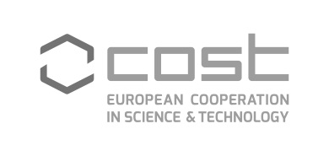 EU-FLAG_cmyk_ai8

COST CA17116 - SPRINT

**International Network**

**for Translating Research on**

**Perinatal Derivatives into**

**Therapeutic Approaches**

**COST CA17116 – SPRINT Meeting**

**27-28 June 2019**

University of Ljubljana

Faculty of Medicine

Institute of Cell Biology

Vrazov trg 2, SI-1000 Ljubljana

Slovenia